Adjacent Angles
# Source: AI Source: Provided by: [Data Path: Persons Table -> ID Column: 1, Name_En Column: Motasem Essam] -> From: [ChatGPT] on [7/25/2026]
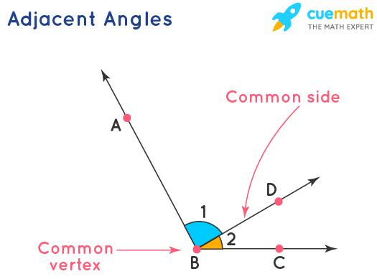
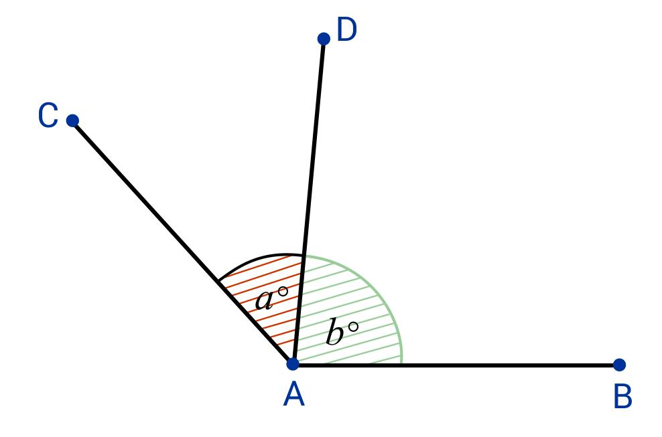
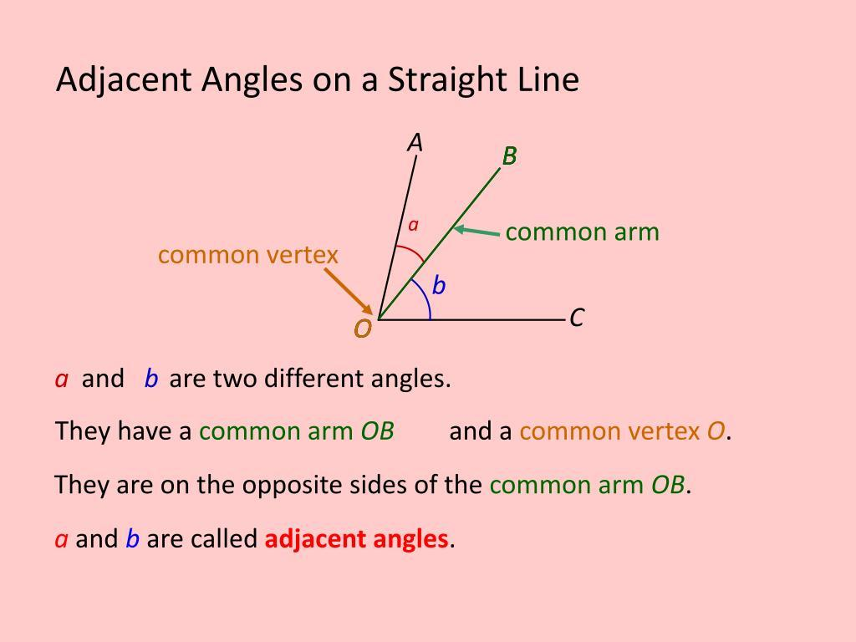
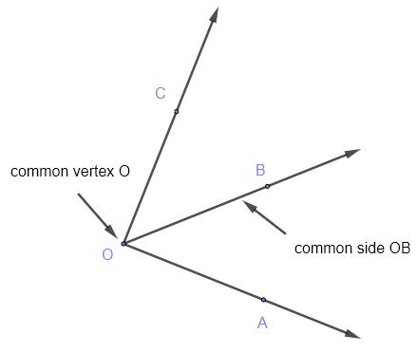
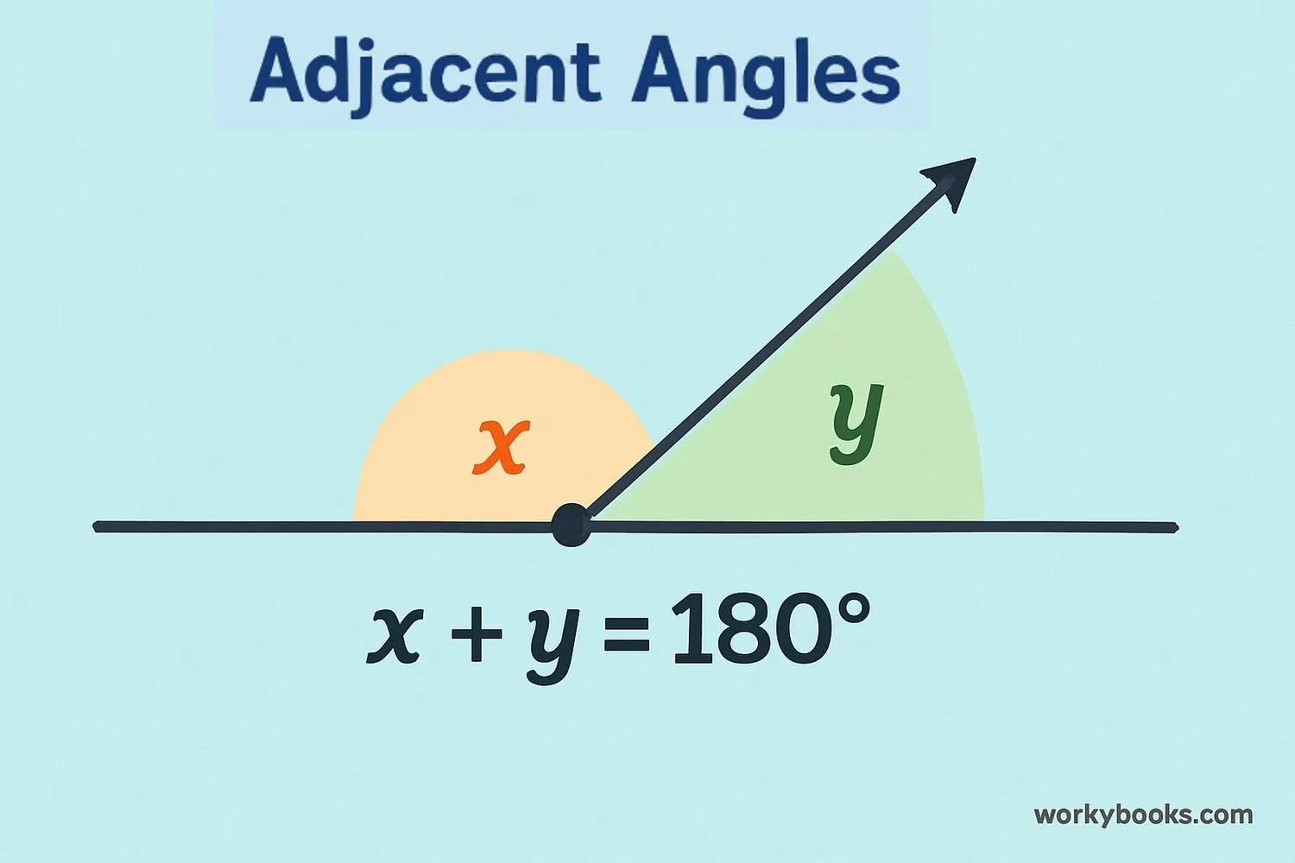
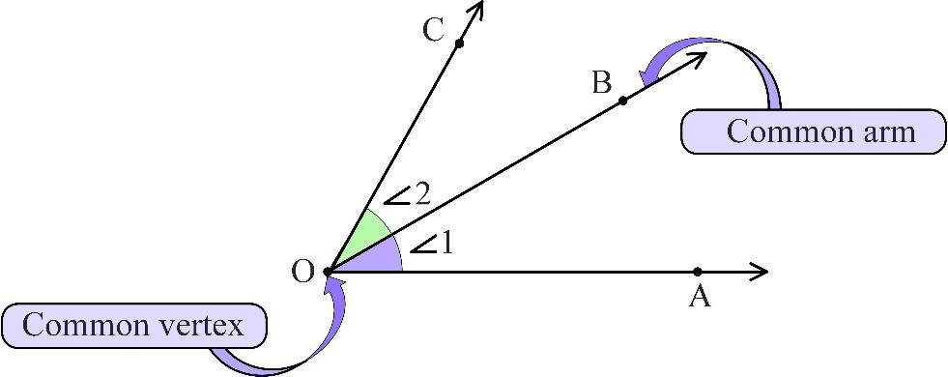

Definition
# Source: AI Source: Provided by: [Data Path: Persons Table -> ID Column: 1, Name_En Column: Motasem Essam] -> From: [ChatGPT] on [7/25/2026]
Adjacent Angles are two angles that share a common vertex, share one common side (ray), and do not overlap.
They are positioned next to each other, with one angle located beside the other.

Characteristics
# Source: AI Source: Provided by: [Data Path: Persons Table -> ID Column: 1, Name_En Column: Motasem Essam] -> From: [ChatGPT] on [7/25/2026]
Adjacent angles:
- Have the same vertex.
- Share one common side.
- Have separate interiors (they do not overlap).
- Are located next to each other.
- May have different angle measures.
- Their measures may be added to find the total angle formed by their union.

Illustration
# Source: AI Source: Provided by: [Data Path: Persons Table -> ID Column: 1, Name_En Column: Motasem Essam] -> From: [ChatGPT] on [7/25/2026]
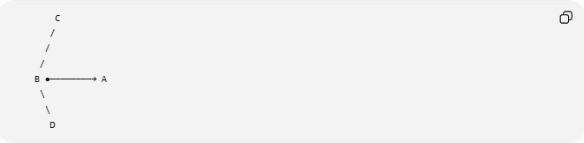
C
/
/
/
B ●────────→ A
\
\
D
The angles:
$$∠CBA$$
and
$$∠ABD$$
share:
- Vertex: $B$
- Common side: $\overset{→}{BA}$
They are adjacent angles.

Mathematical Representation
# Source: AI Source: Provided by: [Data Path: Persons Table -> ID Column: 1, Name_En Column: Motasem Essam] -> From: [ChatGPT] on [7/25/2026]
If two angles:
$$∠ABC$$
and
$$∠CBD$$
share:
- Common vertex $B$
- Common side $\overset{→}{BC}$
then:
$$∠ABC\text{ and }∠CBD$$
are adjacent angles.

Properties of Adjacent Angles
# Source: AI Source: Provided by: [Data Path: Persons Table -> ID Column: 1, Name_En Column: Motasem Essam] -> From: [ChatGPT] on [7/25/2026]
1. Common Vertex
Adjacent angles always have the same vertex.
Example:
$$∠AOB$$
and
$$∠BOC$$
both have vertex:
$$O$$

2. Common Side
Adjacent angles share exactly one side.
Example:
$$\overset{→}{OB}$$
is the common ray.

3. No Overlapping Interior
The inside regions of adjacent angles do not cross.
They only touch along the common side.

4. Angle Addition Property
If two adjacent angles form a larger angle:
$$m∠AOC=m∠AOB+m∠BOC$$
Example:
$${30}^{∘}+{40}^{∘}={70}^{∘}$$

Types of Adjacent Angles

1. Adjacent Acute Angles
# Source: AI Source: Provided by: [Data Path: Persons Table -> ID Column: 1, Name_En Column: Motasem Essam] -> From: [ChatGPT] on [7/25/2026]
Both angles are acute.
Example:
$${30}^{∘}+{20}^{∘}={50}^{∘}$$
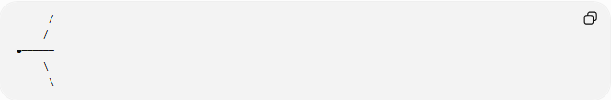
/
/
●──────
\
\

2. Adjacent Right and Acute Angles
# Source: AI Source: Provided by: [Data Path: Persons Table -> ID Column: 1, Name_En Column: Motasem Essam] -> From: [ChatGPT] on [7/25/2026]
One angle is ${90}^{∘}$, the other is acute.
Example:
$${90}^{∘}+{30}^{∘}={120}^{∘}$$

3. Adjacent Supplementary Angles (Linear Pair)
# Source: AI Source: Provided by: [Data Path: Persons Table -> ID Column: 1, Name_En Column: Motasem Essam] -> From: [ChatGPT] on [7/25/2026]
Two adjacent angles whose non-common sides form a straight line.
Their sum is:
$${180}^{∘}$$
Example:
$${120}^{∘}+{60}^{∘}={180}^{∘}$$
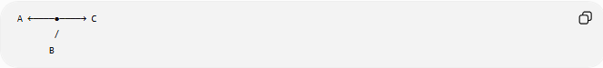
A ←────●────→ C
/
B

4. Adjacent Complementary Angles
# Source: AI Source: Provided by: [Data Path: Persons Table -> ID Column: 1, Name_En Column: Motasem Essam] -> From: [ChatGPT] on [7/25/2026]
Two adjacent angles whose sum is:
$${90}^{∘}$$
Example:
$${45}^{∘}+{45}^{∘}={90}^{∘}$$

Difference Between Adjacent and Other Angle Relationships
# Source: AI Source: Provided by: [Data Path: Persons Table -> ID Column: 1, Name_En Column: Motasem Essam] -> From: [ChatGPT] on [7/25/2026]
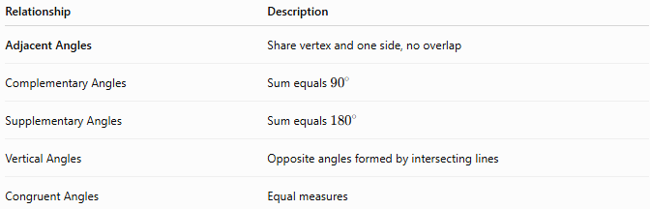
Relationship | Description
Adjacent Angles | Share vertex and one side, no overlap
Complementary Angles | Sum equals ${90}^{∘}$
Supplementary Angles | Sum equals ${180}^{∘}$
Vertical Angles | Opposite angles formed by intersecting lines
Congruent Angles | Equal measures

Examples in Real Life
# Source: AI Source: Provided by: [Data Path: Persons Table -> ID Column: 1, Name_En Column: Motasem Essam] -> From: [ChatGPT] on [7/25/2026]
Adjacent angles appear in:
- Corners of polygons.
- Divisions of a clock face.
- Roof structures.
- Building corners.
- Road intersections.
- Engineering drawings.
- CAD designs.
Example:
A square corner divided by a diagonal creates two adjacent angles.

Applications
# Source: AI Source: Provided by: [Data Path: Persons Table -> ID Column: 1, Name_En Column: Motasem Essam] -> From: [ChatGPT] on [7/25/2026]
Adjacent angles are used in:
- Plane Geometry
- Coordinate Geometry
- Trigonometry
- Engineering
- Architecture
- Construction
- Surveying
- CAD (Computer-Aided Design)
- Robotics
- Computer Graphics

Advantages
# Source: AI Source: Provided by: [Data Path: Persons Table -> ID Column: 1, Name_En Column: Motasem Essam] -> From: [ChatGPT] on [7/25/2026]
Studying adjacent angles helps to:
- Understand angle addition.
- Solve unknown angle problems.
- Analyze geometric figures.
- Construct polygons.
- Understand angle relationships.

Limitations
# Source: AI Source: Provided by: [Data Path: Persons Table -> ID Column: 1, Name_En Column: Motasem Essam] -> From: [ChatGPT] on [7/25/2026]
Adjacent angles:
- Must share a common vertex.
- Must share exactly one side.
- Cannot overlap.
- Are not necessarily equal.
- Are not always complementary or supplementary.

Comparison with Related Concepts
# Source: AI Source: Provided by: [Data Path: Persons Table -> ID Column: 1, Name_En Column: Motasem Essam] -> From: [ChatGPT] on [7/25/2026]
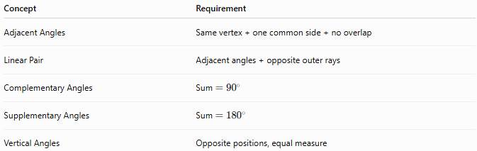
Concept | Requirement
Adjacent Angles | Same vertex + one common side + no overlap
Linear Pair | Adjacent angles + opposite outer rays
Complementary Angles | Sum $={90}^{∘}$
Supplementary Angles | Sum $={180}^{∘}$
Vertical Angles | Opposite positions, equal measure

Key Points
# Source: AI Source: Provided by: [Data Path: Persons Table -> ID Column: 1, Name_En Column: Motasem Essam] -> From: [ChatGPT] on [7/25/2026]
- Adjacent Angles share:
  - The same vertex.
  - One common side.
  - No overlapping interior.
- Their measures can be added:
$$m∠AOC=m∠AOB+m∠BOC$$
- A special case is a linear pair, where:
$$θ_{1}+θ_{2}={180}^{∘}$$

Conclusion
# Source: AI Source: Provided by: [Data Path: Persons Table -> ID Column: 1, Name_En Column: Motasem Essam] -> From: [ChatGPT] on [7/25/2026]
Adjacent Angles are two angles that sit next to each other by sharing a common vertex and one common side without overlapping. They are fundamental in geometry because they allow larger angles to be divided into smaller parts and provide the foundation for understanding angle addition, linear pairs, complementary angles, and supplementary angles. Adjacent angles are widely used in plane geometry, coordinate geometry, trigonometry, engineering, architecture, construction, surveying, CAD, robotics, and computer graphics to analyze connected geometric structures and directional relationships.

